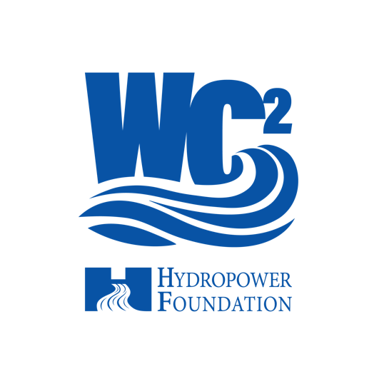
Industry Partners - FAQ

- Who pays for the students to attend industry events, site visits, and competitions?
  - Clubs are given $500 each semester to support any programming they put on. This includes:
    - Club meetings.
    - Industry events as available, i.e.) Hiring for Hydro
    - site visits, etc.
    - If clubs need additional funding, the WC² committee will discuss requests on a case-by-case basis.
- What are some types of events that clubs are hosting?
  - Clubs can host any event that best benefits their school’s Waterpower Club, campus, and community. Some examples of events include:
    - Bringing in speakers to discuss hydropower topics.
    - Volunteering at a local elementary school and presenting a hands-on hydropower activity.
    - Touring a local hydropower facility.
- How frequently do clubs meet?
  - Clubs are expected to meet at a minimum of once a month or four times per semester to receive their $500 funding.
  - Clubs are welcome to meet more often; however, that varies depending on the school.
- What are some topics discussed during meetings?
  - Hydropower and Marine Energy Basics (the fundamentals)
  - Powering non-powered dams
  - Pumped-storage hydropower and the advantages to a clean energy future
  - Waterpower and the environment
  - Careers in waterpower
  - Hydropower and the interplay with other renewable energy technologies
  - Fisheries, fish passage and waterpower
  - Clean water and waterpower
  - Any additional topics that may interest students or that could support them with their Hydro Think Tank Competition or Hydropower Collegiate Competitions.
  - Dam engineering and dam safety considerations
  - Waterpower around the world
- What is provided to students upon establishing a Waterpower Club at a university?
  - Once a Waterpower Club is established, it receives $500 in funding for the year and marketing guidelines for social media posts.
  - The club chair will work with Amanda Neves, our Student and Event Coordinator, to schedule speakers of interest and/or connect the clubs with a local facility tour.
- What is the average size of a club?
  - Club sizes can vary from anywhere to 5-30 students
- How many faculty are involved?
  - Minimum faculty requirement is one.
  - Current clubs have 1-2 faculty members involved.
  - No maximum number of faculty members has been set. The hope is that faculty members from various departments will be involved to encourage a multidisciplinary waterpower club.
- What schools already have clubs established?
  - University of Wisconsin-Platteville
  - Manhattan College
  - Columbia University
  - Texas Tech
  - Wenatchee Valley College
- My organization already has university relationships. Why should we join WC²?
  - 56% of the firms in our industry have identified talent shortages as their number one challenge. By partnering with the Hydropower Foundation and other like-minded organizations, we can significantly benefit the waterpower community. There’s power in numbers!
  - Other organizations are just beginning their student outreach, and you will be able to share best practices.
  - Waterpower Clubs will benefit from a diverse mix of organizations and individuals helping to educate them about waterpower.

