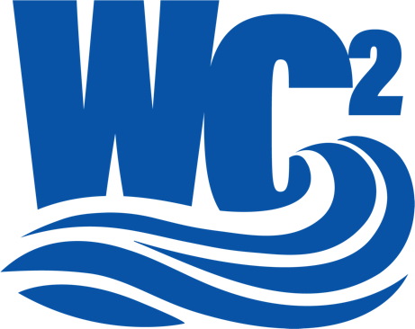

Students and Faculty FAQ

- What do I need to do to start a club?
  - The first step to starting a club is finding a faculty member to serve as the club advisor.
  - Complete the application, available on the WC² website - College and University Partners (hydrofoundation.org).
  - Each school has different requirements that students must follow to establish a Waterpower Club at their school. You can also establish a club and a subgroup of another club with synergies, such as a Sustainability or Renewable Energy Club.
  - Faculty members should be able to help you with the university guidelines; however, we are also available to help.
  - Clubs must get an EIN to create a bank account with your school so we can provide funding each semester.
- What kind of events are expected for the club to host?
  - You can develop any programming that you believe would benefit your school and pertain to waterpower.
  - We only ask that, at a minimum, your club meets once a month or four times per semester. Some ideas for meetings and projects include:
    - Hosting a guest speaker from the waterpower community.
    - Volunteer at your local school and present a hands-on activity on waterpower. (We can help connect you with these activities.)
    - Resume workshops
    - Touring a waterpower facility
    - Build a prototype waterpower project as a team.
    - Work in groups within the overall club on ways to communicate about waterpower in the community. Videos, social media posts, etc. Share the good news of waterpower.
      - Take the good news to a local primary school
- How does the Hydropower Foundation support Waterpower Clubs?
  - The Hydropower Foundation will help you create a club structure and an event schedule.
  - We will also provide marketing guidelines to support you when creating marketing materials to promote your club to more students.
  - We will also provide your club with $500 each semester to support any programming.
- How do we receive funding?
  - Once your school has created an account, we will process your $500 payment.
  - You can expect to receive your funding at the beginning of each school semester.
- What are the benefits of starting a Waterpower Club at my school?
  - Learning about one of the most exciting opportunities for a career in clean energy.
  - Direct line to the” Hiring for Hydro” Career Portal.
  - Career training and mentorship.
  - Access to exclusive scholarship opportunities.
  - Internship and co-op education opportunities.
  - Funded socials and activities.
  - Connecting with industry leaders. And meeting potential employers.

Schools with established clubs:
- University of Wisconsin-Platteville
- Manhattan College
- Columbia University
- Texas Tech
- Wenatchee Valley College

